Welcome to Pymatuning Adventure

RV campground & resort

7562 S Pymatuning Lake Road, Williamsfield, OH 44093

Welcome to Pymatuning Adventure! We are proud to present our unique campground offering the perfect combination of amenities and rustic camping. As a member-based campground, neighbors become friends and friends become family. We are so excited to show you all we have to offer and invite you to become part of the Travel Resorts Family!

Sign Up for Free Camping  
  
https://www.youtube.com/watch?v=Xa8HaeUA6hc

Sign up for great camping experience, it's on us!​​

Pymatuning Adventure is in Ashtabula County in northern Ohio, about 50 miles east of Cleveland and only 30 miles south of Lake Erie. The great Pymatuning Lake, a superior walleye fishery, is only feet away from the resort, although the Pymatuning State Park lies between the resort and the lake, necessitating a short detour.

The resort also features 112 full-service campsites, 38 seasonal sites, 35 large-park models that sleep up to eight people and 11 nice, two-bedroom cabins for those who don’t have their own RV. Full time activity directors make sure that there is something interesting to do on each visit and with so many activities close by you will never run out of things to do!

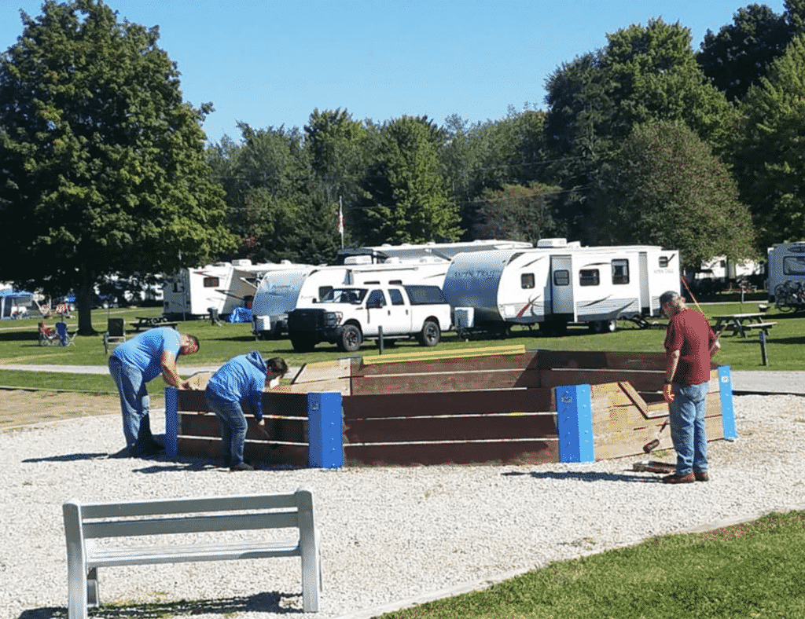

Why Become a Member with Travel Resorts?

Here at TRA, the core of what we do is provide “unlimited camping” in our private RV resort. Our average member uses 19 nights a year.  Most RV sites at other campgrounds cost $75 or more dollars per night and availability is scarce with 900,000 more RV’s on the road all looking to book Friday through Sunday.  Travel Resorts of America saves an average member $1500 a year in site fees, not to mention when the member books in their reservation window of 30-90 days they are not competing against the public but only against the members with the same reservation window.  We will be adding sites and resorts every year and updating our current ones to enhance membership satisfaction.  
  
With many different memberships available, you can choose the one that is right for you and your family, whether that be camping 2 times a year or 200! Travel Resorts caters to all types of campers, from first timers to those who love living the RV life. With tent camping, RVs and cabins we are suited for EVERYONE! Including you!  
 [Become a Member](https://travelresorts.com/how-to-become-a-member/)  
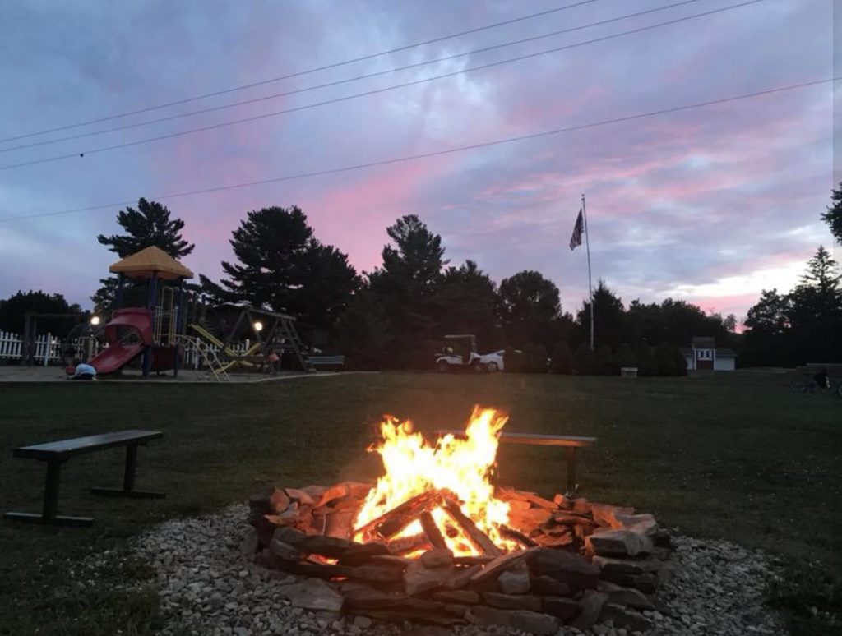  
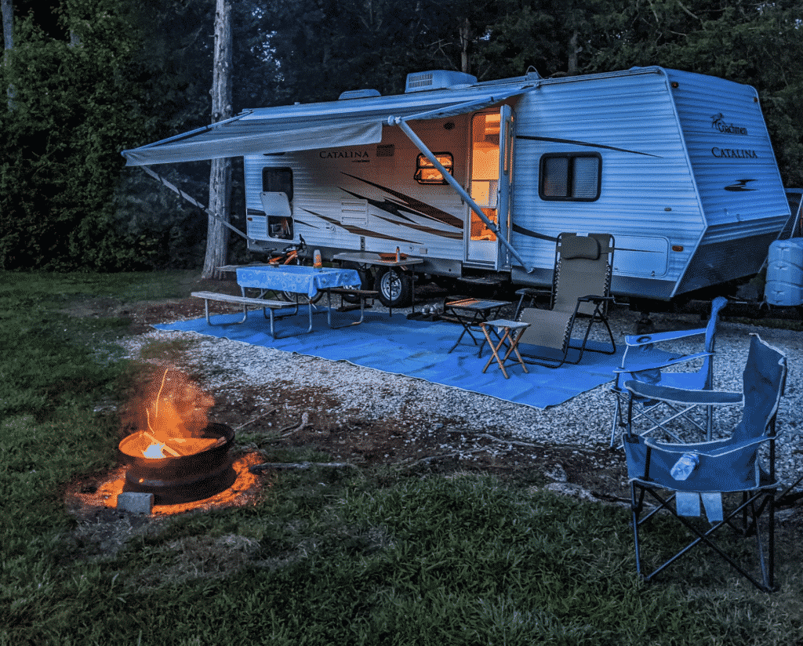  
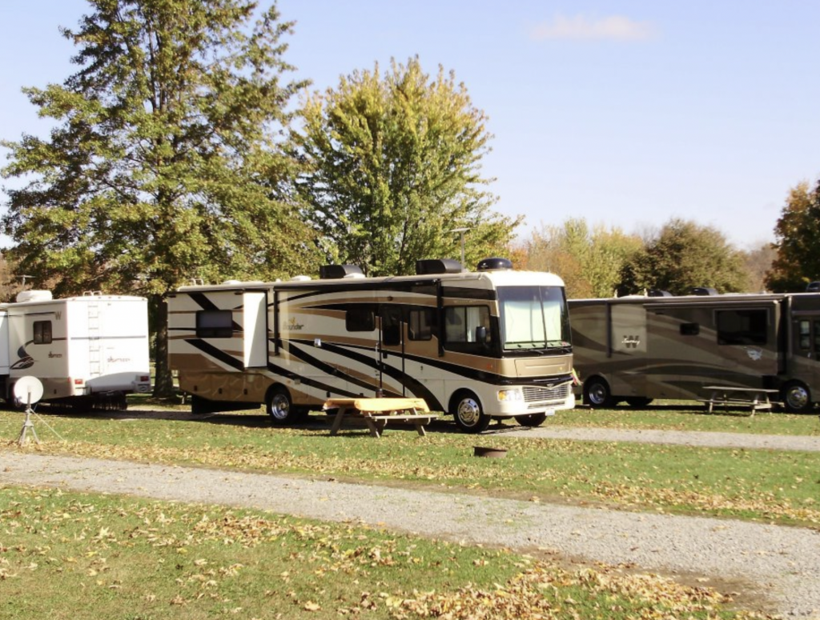

Additional Benefits Offered

We are also proud to offer with our membership access to exclusive programs like, Coast to Coast, Hop Away Holiday and our new member experience, Ask Roscoe! What is all of that you ask?

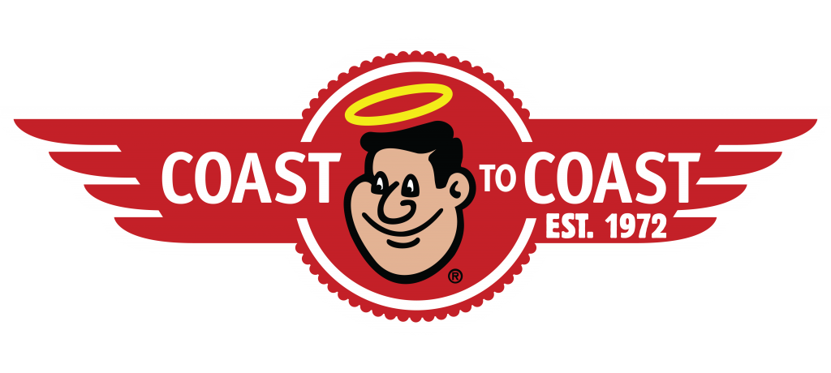

One of the awesome benefits of becoming a member of Travel Resorts, is the Coast-to-Coast package. This offers members an exclusive range of vacation choices for you and your family. The Coast network includes some of the nation's best outdoor resorts with immaculate campsites, on-site security, superior amenities, and legendary reputations for going beyond when it comes to taking care of our guests.

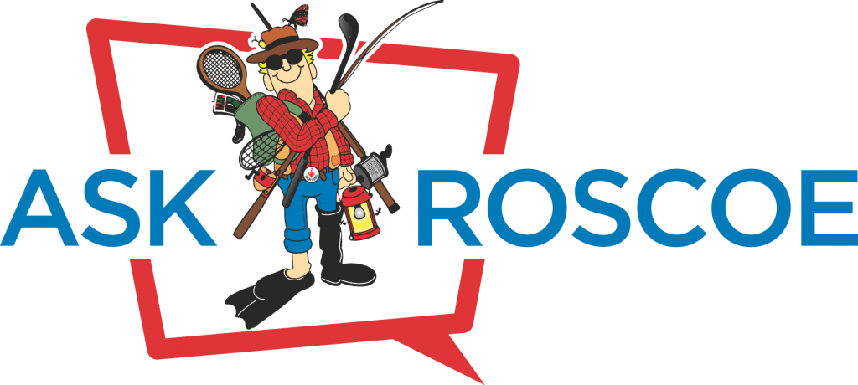

This exclusive membership gives you access to all the cheapest hotels, flights, cars, and condominiums available. With over 1,000,000 properties around the world and a 110% best price guarantee, you can be confident you and your family will have the affordable vacation of your lifetime!

More of Our Resorts

[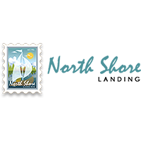](https://www.northshorervpark.com/)

[Northshore Landing Resort](https://www.northshorervpark.com/)

Greensboro, GA  
  
(855) 432 8457

[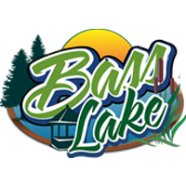](https://basslakeresort.com/)

[Bass Lake Resort](https://basslakeresort.com/)

Parish, NY 13131  
  
(855) 432 8457

[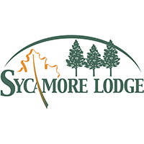](https://campnorthcarolina.com/)

[Sycamore Lodge Resort](https://campnorthcarolina.com/)

Jackson Springs, NC  
  
(855) 432 8457

[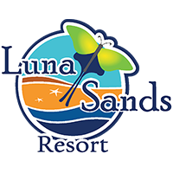](https://lunasandsresort.com/)

[Luna Sands Resort](https://lunasandsresort.com/)

Orange City, FL  
  
(855) 432 8457

[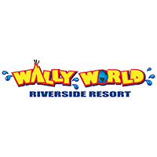](https://wallyworldresort.com/)

[Wally World Riverside Resort](https://wallyworldresort.com/)

Loudonville, OH  
  
(855) 432 8457

[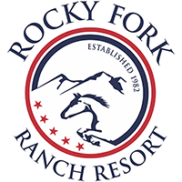](http://rockyforkranchresort.com/)

[Rocky Fork Ranch Resort](http://rockyforkranchresort.com/)

Kimbolton, OH  
  
(855) 432 8457

[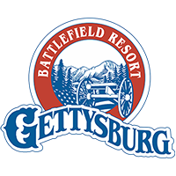](https://campgettysburg.com/)

[Gettysburg Battlefield Resort](https://campgettysburg.com/)

Gettysburg, PA  
  
(855) 432 8457

Camp is Open

From April 1st till October 31st

[(855) 432-8457](tel:8554328457)

Office Hours

Mon - Thu: 09:00 AM - 07:00 PM

Friday: 09:00 AM - 10:00 PM

Saturday: 09:00 AM - 08:00 PM

Sunday: 09:00 AM - 07:00 PM

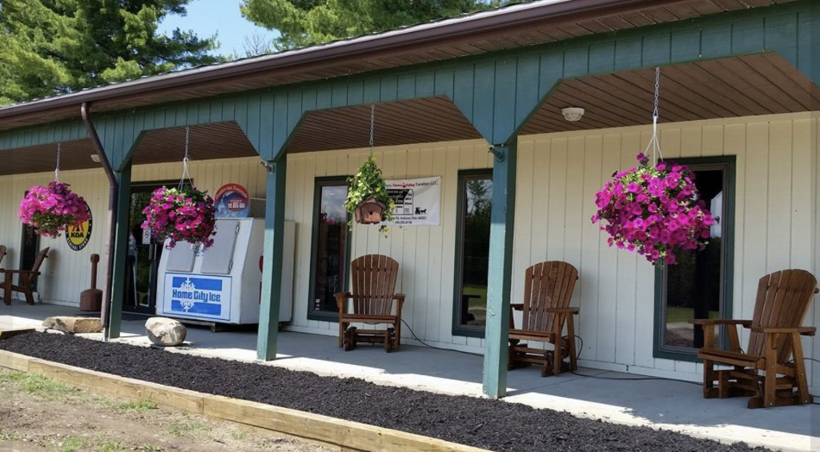

Frequently asked questions

What are the link to Coast to Coast or Hopaway Holidays?

Here they are:

[https://coastresorts.com/](https://www.coastresorts.com/)

<https://hopawayholiday.com/login.php>

How many resorts do you have?

Travel Resorts of America is proud to offer 8 different resorts to our members. Those include:

[Rocky Fork Ranch- Kimbolton, OH](https://pymatuningadventureresort.com/)

[Luna Sands Resort- Orange City, FL](http://lunasandsresort.com/)

[North Shore Landing-Greensboro, GA](https://northshorervpark.com/)

[Bass Lake- Parish, NY](https://basslakeresort.com/)

[Sycamore Lodge- Jackson Spring, NC](https://campnorthcarolina.com/)

[Gettysburg Battlefield Resort- Gettysburg, PA](https://campgettysburg.com/)

[Wally World Riverside Resort- Loudonville, OH](https://wallyworldresort.com/)

How can I make reservations?

You can login to [camplife.com](https://www.camplife.com/) or call the reservations desk at [(855) 432-8457](tel:8554328457%E2%80%8B%E2%80%8B)

What amenities do you offer?

While all our resorts differ, we are happy to offer our guests many top tier amenities including:

Indoor and outdoor pools

Showers/Changing Areas

Wifi

Fire Pits

Fishing

Golf Cart Rentals

Horseback Riding

Honey Wagon (Black/grey water disposal)

Mini Golf

Planned activities throughout the year

Paintball

Laundry

Arcade Games

Billiards

What type of sites, hookups and equipment do your resorts allow?

Pull through and back in Sites

5th Wheel, Class A, Class B, Class C (up to 45 feet in length)

30 Amp and 50 Amp Hookups

Sewer and water Hookups

If your question is not listed here, feel free to Contact Us.

What our members say

*Edna Yard* Read More  
We live in Florida and have family & friends in NY. When traveling in our motorhome, Pymatuning adventure park has been our favorite stop for the past 10-12 years! Always clean & neat, friendly service, pool, dog park store etc.  
*George Craffey* Read More  
Very clean and well-kept Campground staff is superb highly recommended the place.  
*David Liebro* Read More  
Great place. The people are very nice and welcoming. Recommend everyone i know to this campground.  
*Donulus Schantz* Read More  
One of our favorite camping spots.  
[hfe_template id='126']